Wire Transfer Information in Voyager Vendor Records
Main screen (address 1)
Vendor type : Foreign wires (or Domestic wires)
Note that “foreign” or “domestic” refers to the Bank address, not the Vendor address.
Bank information tab
a.Bank account : Enter bank account number in this field if you have one. If not, enter the word Account.
b.Transit/Routing : SWIFT number (number only, no label)
c. Bank name – Name of the bank from the spreadsheet (this info is not transmitted in the vendor file and has no format template)
d. Address 1 –Benefit , etc ( 50 character max). Use format
Benefit: [space] [name of individual or company]
e. Address 2 – IBAN number (no label. No spaces or hyphens). Be sure the first 2 letters are uppercase.
f. City and country – not being transmitted in the voucher file, no format template
Payment address
Remove any information currently in the payment address. Enter the following fields:
- Attention : See Bank information tab
- Address line 1 : Wire transfer. Do not update this address.

See sample screenshots on next pages

Bank information tab

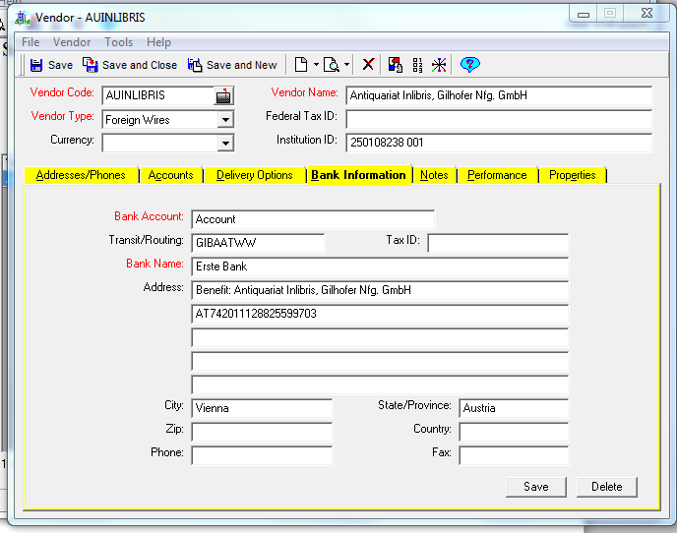

Payment address
